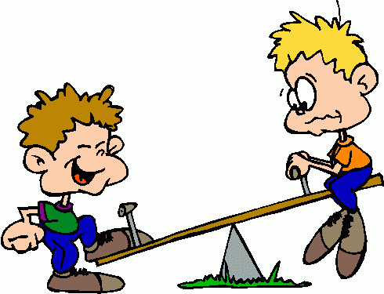
Levers Investigation

Outcomes: Science Inquiry; Science Understanding: Physics

Aim: To find out how length of levers can create a force advantage.

Prediction: What will the effect of the length of a lever be on the force it can produce?

______________________________________________________________________________________________________________________________________________
Follow instructions to complete the experiment.

Apparatus: Draw a labelled scientific diagram for your experiment. Include a caption.

Results:
Write a title for your table.
Write headings for each column (don’t forget units).
Record your results in the table below.

_______________________________________________________________________

 | 1 | 2 | 3 | Ave

Graph your results.

Discussion:

What was your independent (changed) variable?

_______________________________________________________________________

What was your dependent (measured result) variable?

_______________________________________________________________________

What were three controlled (kept the same) variables?

_____________________________________________________________________________________________________________________________________________________________________________________________________________________

Did you have any uncontrolled variables?

_____________________________________________________________________________________________________________________________________________________________________________________________________________________

Summarise your results.

_____________________________________________________________________________________________________________________________________________________________________________________________________________________

Explain your results.
___________________________________________________________________________________________________________________________________________________________________________________________________________________________________________________________________________________________________________________________________________________________________

Did you have any difficulties or problems with your experiment?

_____________________________________________________________________________________________________________________________________________________________________________________________________________________

How would you fix this problem if you did this experiment again?

___________________________________________________________________________________________________________________________________________________________________________________________________________________________________________________________________________________________________________________________________________________________________

Conclusion:
What was the overall result?
_______________________________________________________________________
Was your prediction correct?
_______________________________________________________________________

 |  | Mark Allocation |  | Mark
Prediction | - Write a prediction which relates length and force |  | 1
Diagram | - All equipment is labelled, including sizes or types where appropriate.  - Diagram is neat, drawn in pencil, of suitable size, stylised and two dimensional  - Diagram has suitable caption (eg Figure 1: …) |  | 3
Results | - Table title relates variables  - Headings include units where appropriate  - Average calculated for repeat trials |  | 3
Graph | - Graph title relates variables  - Graph type is appropriate for data  - Axis are correct orientation and labelled, including units; Graph is appropriate size and scale |  | 3
Variables | - Independent variable is identified  - Dependant variable is identified  - 1-3 controlled variables identified  - At least one uncontrolled variable identified |  | 4
Discussion | - Results summarised (overall trend)  - Explains results in terms of mechanical advantage  - Difficulties or sources of error identified  - Suggestion for improvement |  | 4
Conclusion | - Summary of findings  - Prediction correct or not |  | 2
Total
/20

